A web application is any software application whose services can be accessed via the Web.

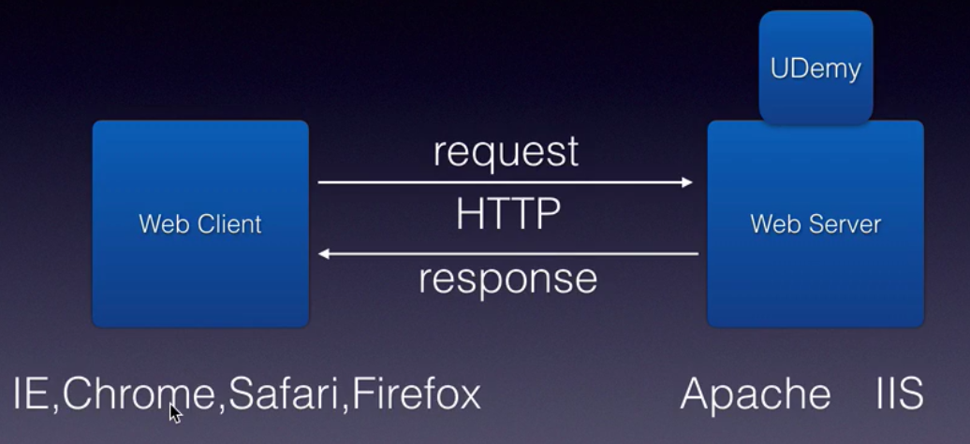
The communicatoin between client and server happens using the HTTP protocol.

To access a website, you use a URL (Uniform Resource Locator).

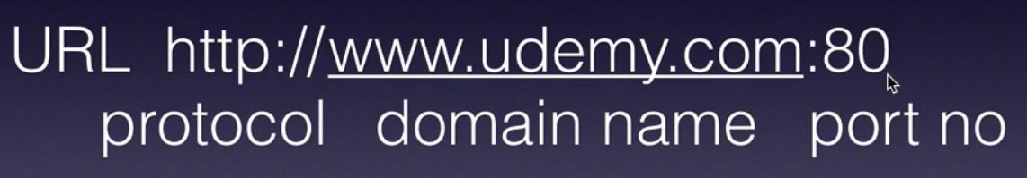

Static Vs Dynamic Web applications :

static web application – non interactive web application. Same information returned to all client requests.

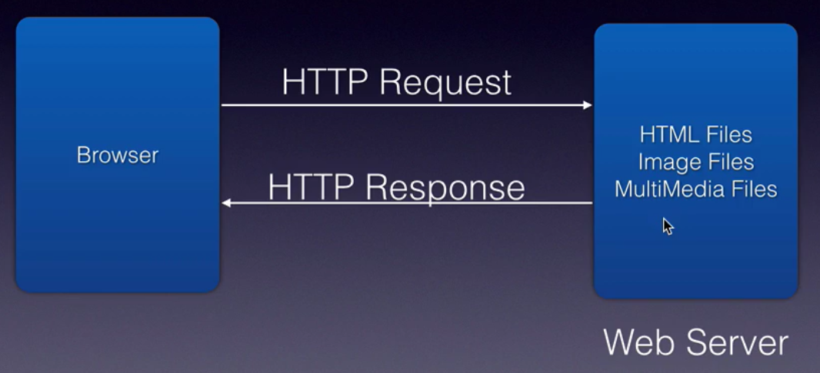
Dynamic web applications – uses server side processing and generate web site content on the fly. Uses web container for server side processing.

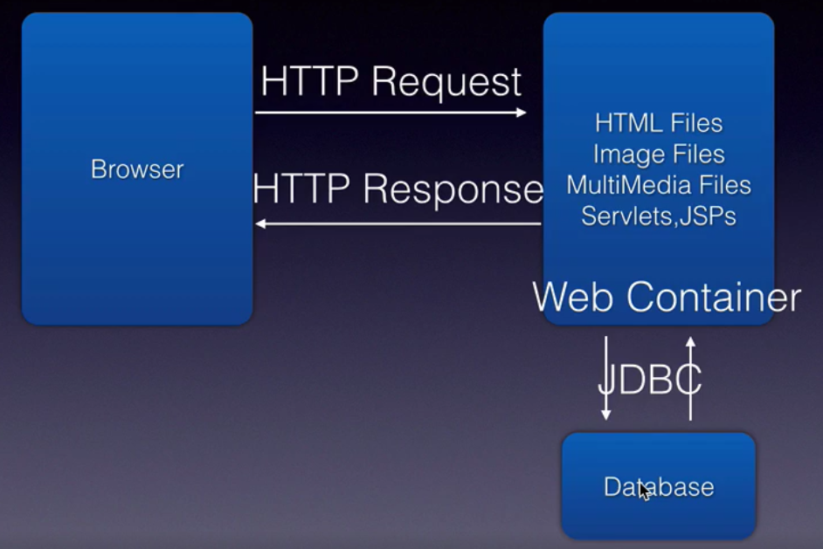

Server side programming :

Different steps involved in dynamic web applications.

